

**CAMPUS MUNCHIES**

**fast food management system**

**Software Requirement Specification**

– CanTho, September 2023 –

**Record of changeS**

| **Date** | **A* M, D** | **In charge** | **Change Description** |
| --- | --- | --- | --- |
| 20/10/2023 | M | TienDS | Change Forgot password(I.2.b) |
| 21/10/2023 | M | TienDS | Change Entities Description(I.3) |
| 23/10/2023 | M | TienT | Change Context diagram(I.1) |
| 23/10/2023 | M | TienT | ChangeEntity Relationship Diagram(I.3) |
| 24/10/2023 | M | TienDS | Change User Authorization(I.2.c) |
| 24/10/2023 | A | TienDS | Add function Functional Requirements(II) |
|  |  |  |  |
|  |  |  |  |
|  |  |  |  |
|  |  |  |  |
|  |  |  |  |
|  |  |  |  |

*A - Added M - Modified D - Deleted

**Table of Contents**

### 

**I. Overview 3**

1. Introduction 3

2. System Functions 4

a. Screen Flow 4

b. Screen Details 5

c. User Authorization 7

d. Non-Screen Functions 8

3. Entity Relationship Diagram 9

**II. Functional Requirements 10**

1. Login System 10

a. Login 10

b. Register 10

c. Forgot Password 11

2. Order Food System 12

a. Show all food (Menu) 12

b. Add to cart 12

c. Show/Edit cart and order 12

d. Show Orders 13

3. Food Management 14

a. Update Product 14

b. Delete Product 14

c. Add Product 14

4. Account Management 15

a. Edit profile 15

b. View employee and customer information 15

c. Create account 17

d. Delete account 17

5. Order Management 18

a. Order Details 18

b. Analytics 19

### 

# I. Overview

## 1. Introduction

Campus Munchies is a website that sells fast food. The idea of this website came from us when we were working together in a group and the whole group seemed to be hungry. Instead of sending one person out to buy food, why? Why don't we order food through a fast food website? The design of this website is inspired by famous food brands such as KFC, Jollibee, and McDonald's.

Campus Munchies is a unique and exciting website project that we have created to meet the needs of students and urban dwellers alike. With a familiar and friendly name, CampusMunchies is committed to delivering memorable, quick, and convenient culinary experiences.

We understand that modern life demands flexibility, and time is always a precious commodity. That's why CampusMunchies was born – to help you save time and enjoy your favourite meals without having to leave your school campus or workplace.

With a diverse menu of fast-food options, from delicious sandwiches to enticing soups and fresh pizzas, you can easily choose dishes that suit your taste with just a few clicks. We also pledge to ensure the quality and freshness of each product so that you're always satisfied with every meal you order from us.

CampusMunchies is not just a fast food delivery website. It's an essential part of modern urban life, helping you relax and recharge to continue successfully on your academic and professional journey. Join us today and experience the convenience and efficiency that CampusMunchies brings to your life!

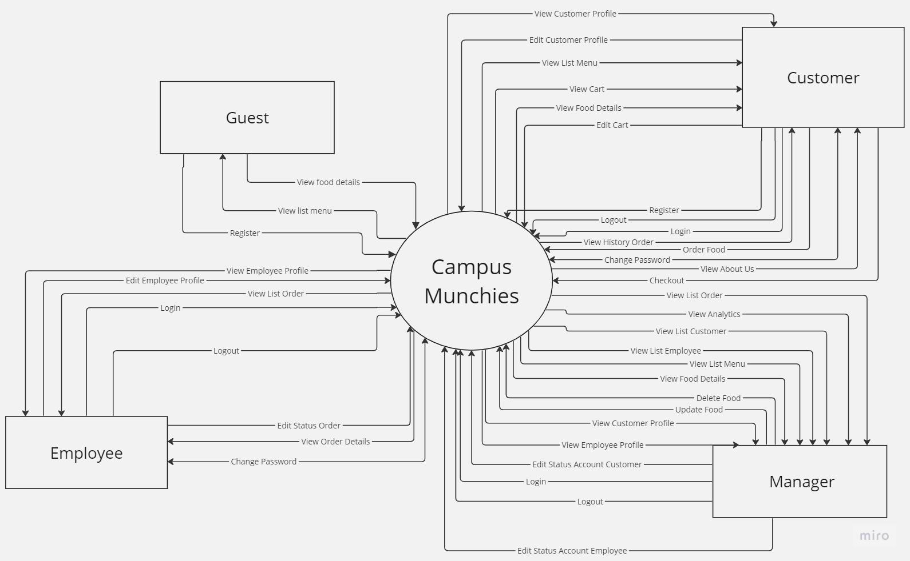

Context diagram

## 2. System Functions

#### a. Screen Flow

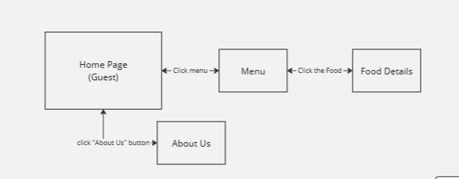

**Guest’s Screen Flow**

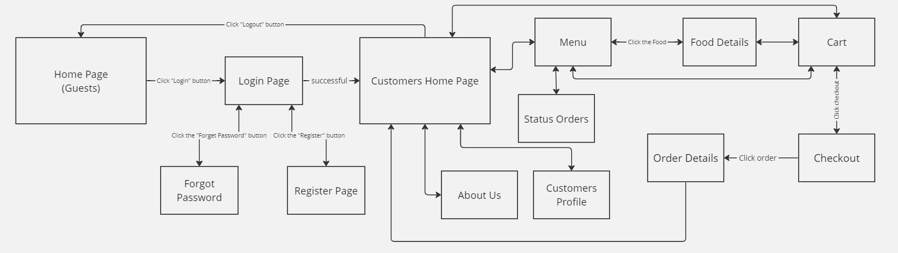

**Customer’s Screen Flow**

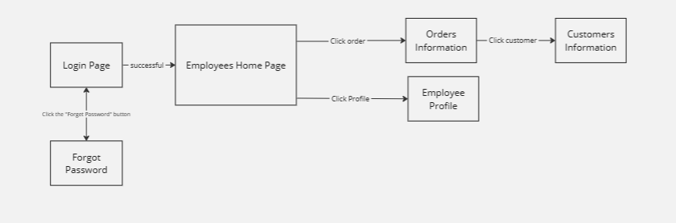

**Employee’s Screen Flow**

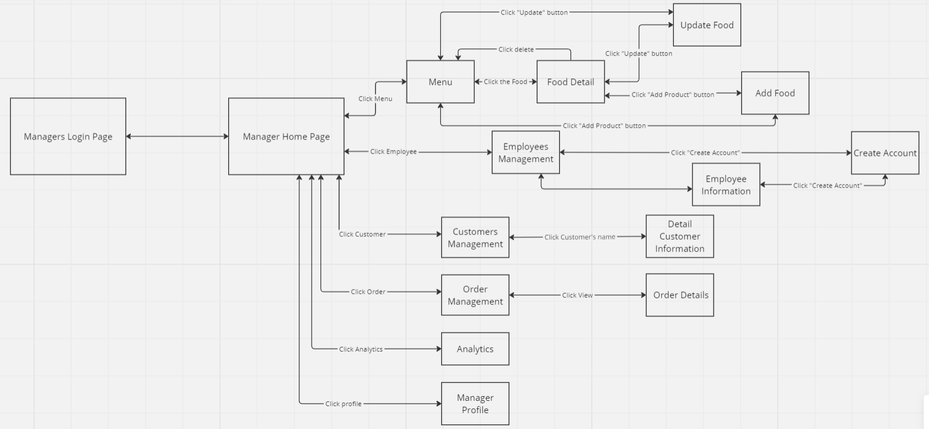

**Manager’s Screen Flow**

#### b. Screen Details

| **#** | **Feature** | **Screen** | **Description** |
| --- | --- | --- | --- |
| 1 | Sign In | Login Page, Manager Login Page | Login to the system with your existing account and password. |
| 2 | Forgot Password | Forgot Password | If the customer already has an account, the system will let the customer enter an email. Then, from the email, the system will send the OTP code via email that the customer has registered within 60 seconds. Customers will get the OTP code from the email and enter it into the system. If the time expires, the OTP code will expire. The system will let customers get a new OTP code. If the OTP code is correct, the customer will generate a new password, otherwise the system will send a new OTP code. |
| 3 | Sign Up | Register Page | Users can register for an account on the website. |
| 4 | Edit Profile Account | Customer Profile, Employee Profile | Users can edit previously created account information. |
| 5 | View All Product | Menu, Customer Home Page | At the website, customers can see all the products being sold at the store. |
| 6 | View Detail Product | Food Detail | Customers can view product details. |
| 7 | View store contact information | About Us | Customers can view contact information about the store. |
| 8 | Search Food | Customers Home Page, Menu | Customers can search for products on the website to find the products they want. |
| 9 | Add To Cart | Menu | Customers can add products to their cart and continue shopping. |
| 10 | View Cart | Cart | Customers can review their cart. |
| 11 | Edit Cart | Cart | Customers can edit and delete added products in the shopping cart. |
| 12 | Proceed to order | Checkout | When the customer wants to proceed with the order, the order page will be provided to fill in all the shipping information. Customers will then choose 1 of 2 payment methods: cash or bank transfer. |
| 14 | Edit Order | Status Order | Customers can view and cancel orders placed. |
| 15 | View Order History | Status Order | Customers can view a list of purchased orders. |
| 16 | View All Product | Manager Home Page, Menu(Manager) | The manager can view the products listed for sale at the website as customers but there is no ordering feature |
| 17 | View Detail Product | Food Detail(Manager) | The manager can view product details but there is no ordering feature. |
| 18 | View Information Account Customer | Customers Management, Detail Customer Information | The manager can view customer information. |
| 19 | View Order History | Order Management | The manager can view the order history of customers who have purchased. |
| 20 | Edit Profile Account Manager | Manager Profile | The manager can edit previously created account information. |
| 21 | Add Food | Menu, Food Detail | The manager has the right to add products to the website according to the form provided. |
| 22 | Edit Food | Menu, Food Detail | The manager has the right to edit or delete products. |
| 23 | View Information Account Employee | Employees Management | The manager can view employee information. |
| 24 | Add Account Employee | Create Account | The manager creates accounts for employees. |
| 25 | Delete Account Employee | Employees Information | The manager deletes accounts employees on the website. |
| 26 | View website analytics | Analytics | The manager can view relevant data information of the website such as revenue, number of customers,... |
| 27 | View All Order | Employee Home Page | Employees can see a list of all the orders placed by the customer. |
| 28 | Edit Status Order | Orders Information | Employees can change the status and status of the customer's order. |
| 29 | View Order Details | Orders Information | Employees can view order details. |
| 30 | View Guest Information | Customers Information | Employees can view customer information to contact. |

#### c. User Authorization

| **Screen** | **Guest** | **Customer** | **Employee** | **Manager** |
| --- | --- | --- | --- | --- |
| Guest Home | X | X | X |  |
| Login |  | X | X |  |
| Login (Managers) |  |  |  | X |
| Logout |  | X | X | X |
| Register | X | X |  |  |
| Forget Password |  | X |  |  |
| Customer Home Page |  | X |  |  |
| Employee Home Page |  |  | X |  |
| About Us | X | X |  |  |
| Status Order |  | X |  |  |
| Account Information |  | X | X | X |
| Cart |  | X |  |  |
| Checkout |  | X |  |  |
| Food detail |  | X |  |  |
| Order Information |  | X | X | X |
| Guest Information |  |  | X | X |
| Manager Home |  |  |  | X |
| Menu Management |  |  |  | X |
| Food detail(Manager) |  |  |  | X |
| Employee Management |  |  |  | X |
| Create Account |  |  |  | X |
| Customer Management |  |  |  | X |
| Order Management |  |  |  | X |
| Analytics |  |  |  | X |
| Manager Profile |  |  |  | X |

In which:

* Guest: Who visits the website without their intention of registering an account.
* Customer: Who creates accounts, register and login to use all the services of the website.
* Employee: Who serve customers, take care of customers, manage customer information, orders, and product information.
* Manager: Who manages employee information, customer information and manages the website.

#### d. Non-Screen Functions

| **#** | **Feature** | **System Function** | **Description** |
| --- | --- | --- | --- |
| 1 | User login. | Authenticate user identity when they enter login information. | The system must check the login information, including username and password, and provide access to the user after they have successfully authenticated. |
| 2 | Login with social network accounts. | Allows users to log in with accounts from social networks like Google. | The system must integrate with social networking services to provide a convenient login method for users. |
| 3 | Database management. | Stores and manages application data. | The system must be able to add, modify, and delete data in the database, including protecting data against problems such as data loss or data corruption. |
| 4 | Send notification email. | Send automatic emails to notify users about important events. | The system must be able to send email notifications to users when there are events such as successful registration confirmation, password reset code, and order delivery. |
| 5 | Security management. | Manage access rights and data security. | The system must allow administrators to define user access rights and protect data from unauthorised access. |
| 6 | User account management. | Allows users to change personal information and passwords. | The system must provide an interface for users so they can securely update their account information and change their passwords. |
| 7 | Optimise network latency. | Uses optimization techniques to reduce network latency when loading pages. | The system optimises website loading by minimising network latency, using techniques such as the HTTP/2 standard, and using servers close to the user's geographical location. |
| 8 | Responsive user interface. | Adjusts the user interface based on the screen size of the user device. | The system ensures that the user interface adapts to different screen sizes, from desktop to mobile, to improve user experience. |

## 3. Entity Relationship Diagram

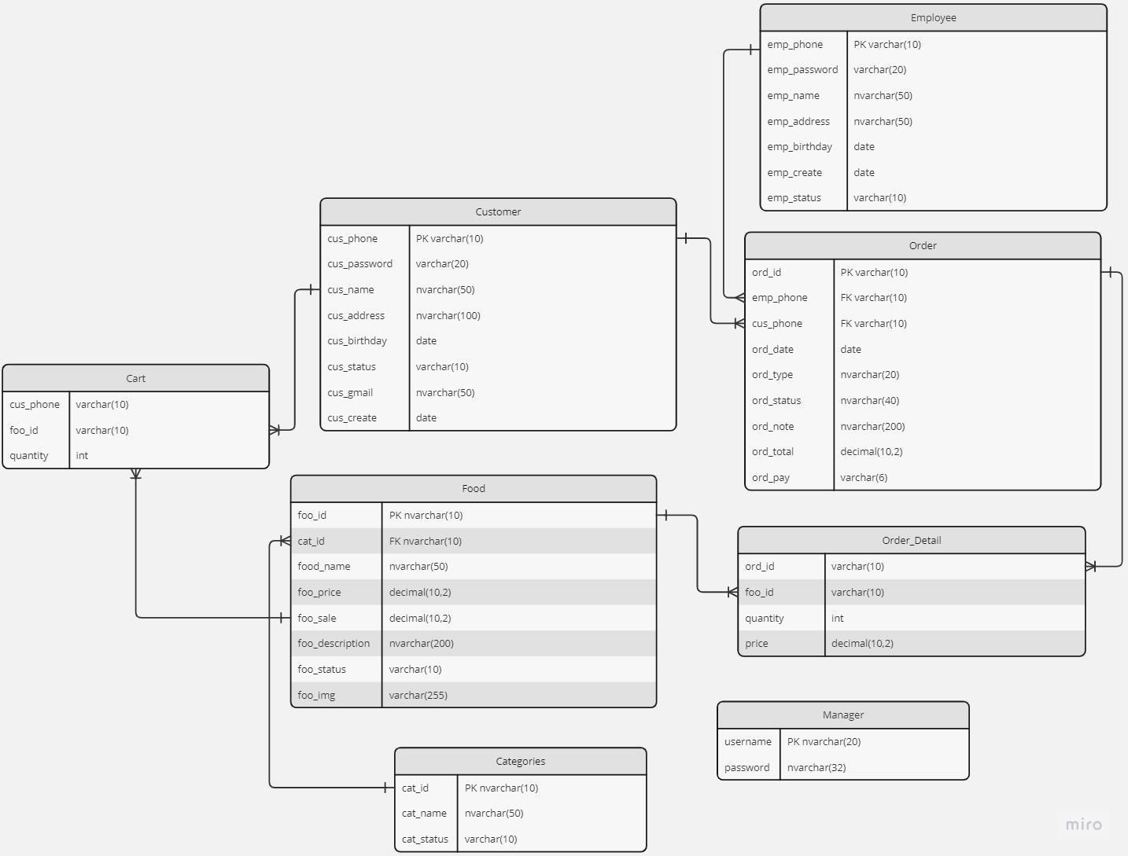

ERD

**Entities Description**

| **#** | **Entity** | **Description** |
| --- | --- | --- |
| 1 | Employee | This entity stores employee information |
| 2 | Customer | This entity stores customer information |
| 3 | Order | This entity stores order information |
| 4 | Manager | This entity stores the manager's account information |
| 5 | Food | This entity stores information about all food |
| 6 | Category | This entity contains product category information |
| 7 | Order Detail | This entity stores order detail information |
| 8 | Cart | This entity stores cart information |

# II. Functional Requirements

## Login System

### Login

* Function trigger: When clicking the “Login” button on the home page
* Function description: Login is the basic and important function for a selling website. It helps them save the customers easier to buy food
* Screen Layout: Employees' and customers' screens should look beautiful, but managers’ screens don’t have to.

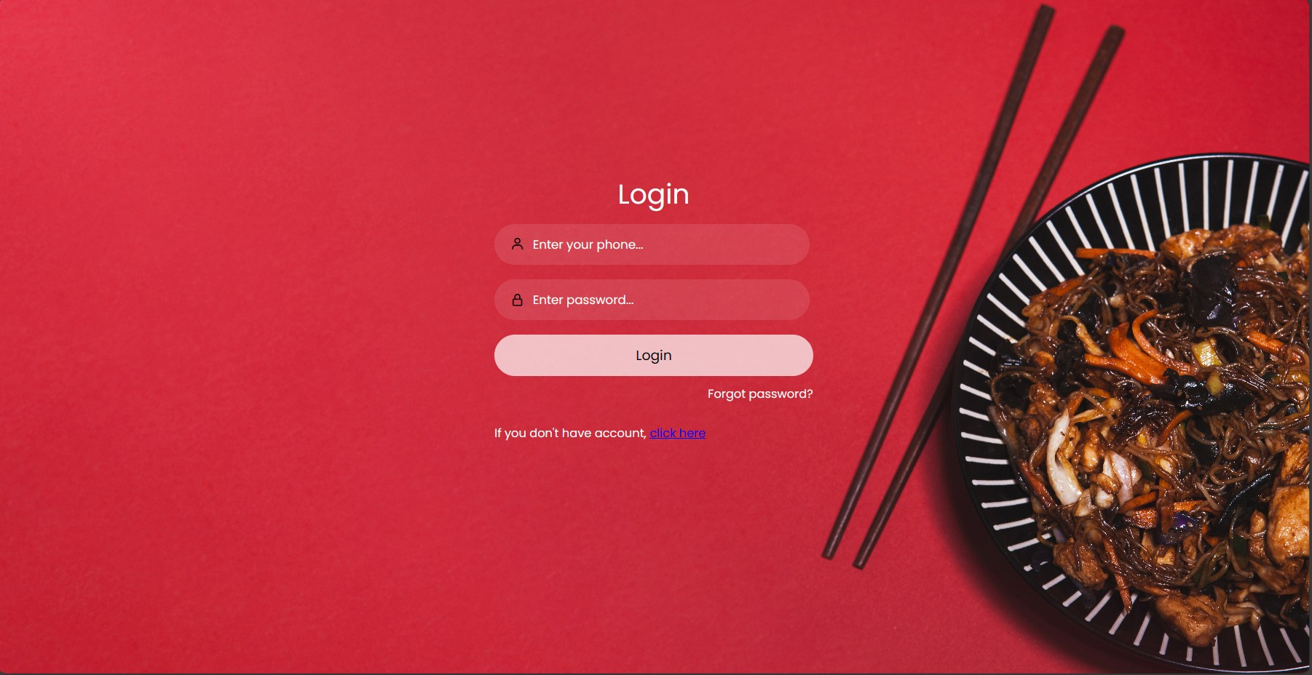

*Customer Login*

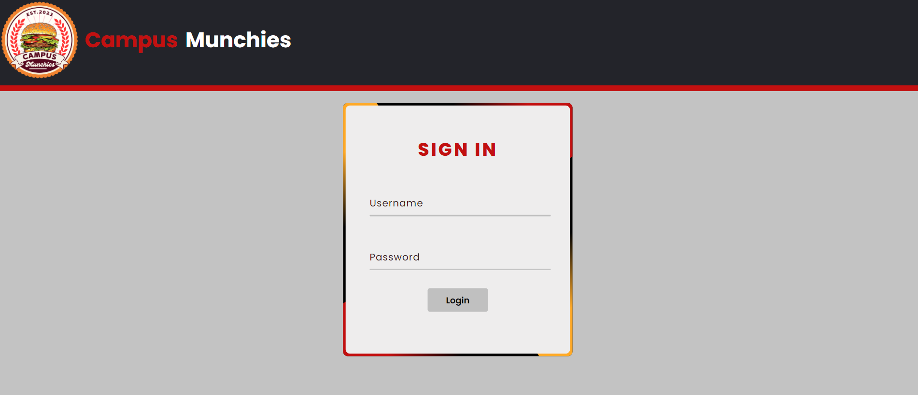

*Employee and ManagerLogin*

* Function Details: Customer and Employee will log in to the same website and Managers have a different website. After login, depending on their role, it brings users to the corresponding home page

### Register

* Function trigger: When clicking the “Register” button on the Login page
* Function description: Help customers create a new account
* Screen Layout: customers' screens should look beautiful and show enough forms for customers to input. Sample below here

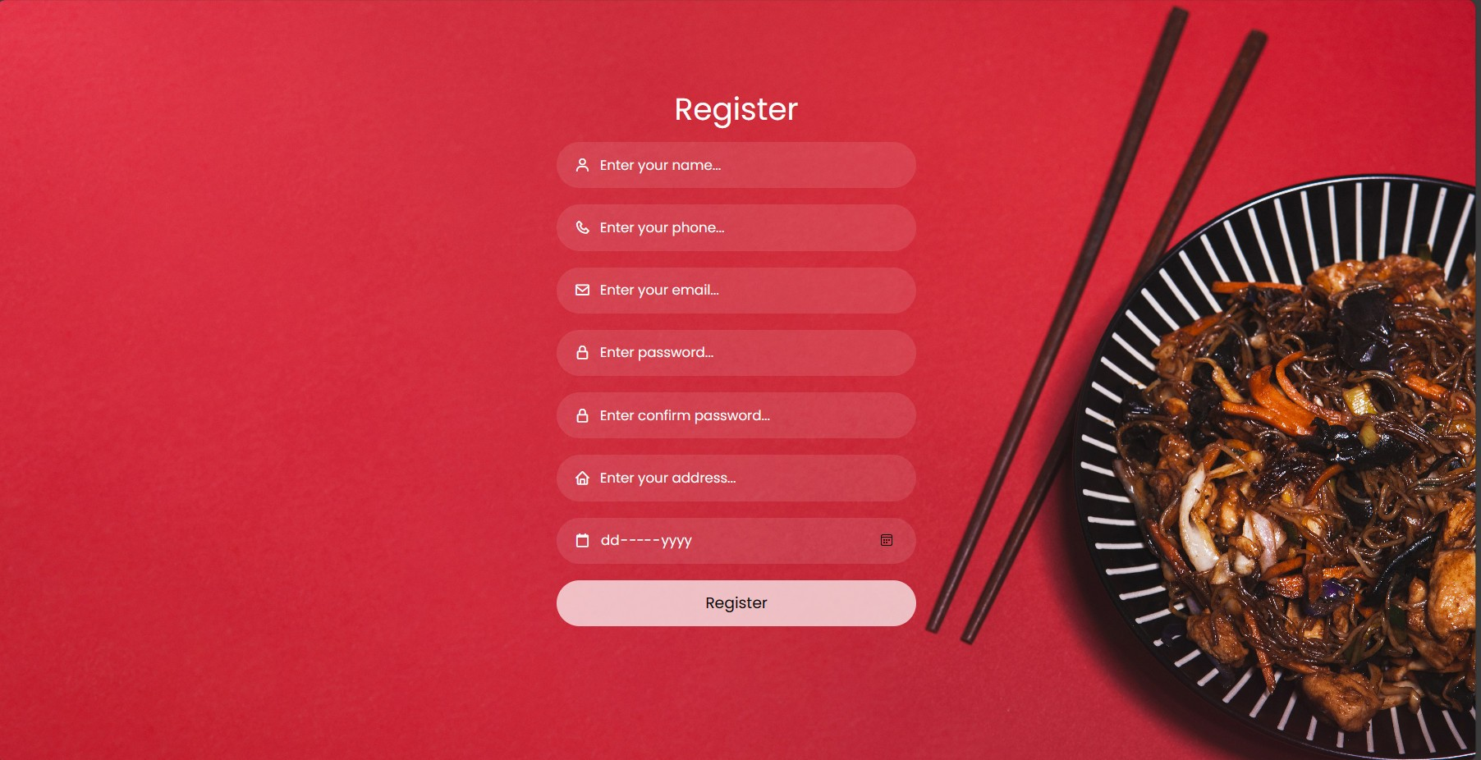

* Function Details: Only the customers can register, employees accounts will be created by managers. The system will check the validation such as phone, password, etc... If it is valid, the information will be put into the database

### Forgot Password

* Function trigger: When clicking the “Forgot the password” button on the Login page
* Function description: Help customers and employees change their password if they forget
* Screen Layout: Sample below here
* 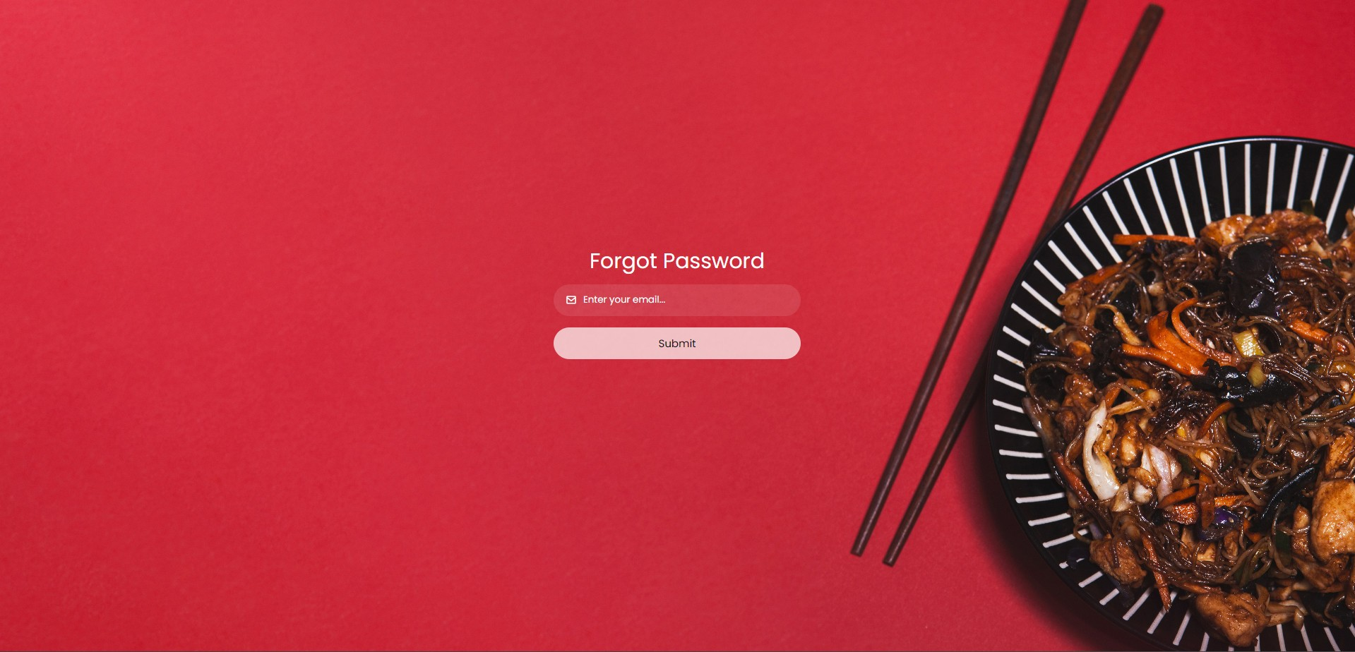
* Function Details: When inputting the phone numbers, it will send an OTP for validation then it opens another website that can write the new password

### 

## 2. Order Food System

### Show all food (Menu)

* Function trigger: When clicking the “Menu” button on the Home page
* Function description: Show all the food on this page
* Screen Layout: Use paging to easy to see

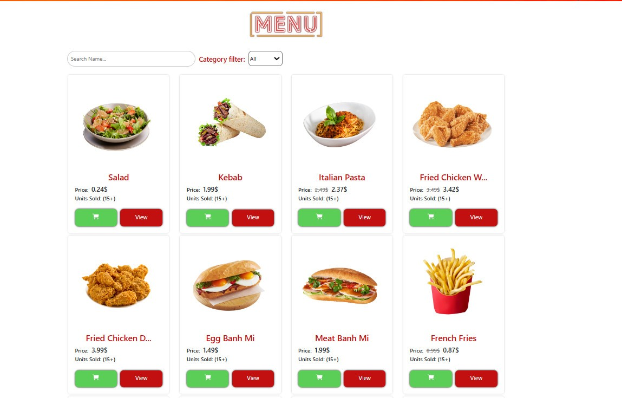

* Function Details: Customers can view the entire food, and click the food to show more. Customers can click “Buy” or “Add to cart”

### Add to cart

* Function trigger: When clicking the “Cart” button on the food on the Home page
* Function description: Put the food they want to buy into cart
* Function details: Customers can add food directly in the Menu Page or show more details then click “Add to cart”



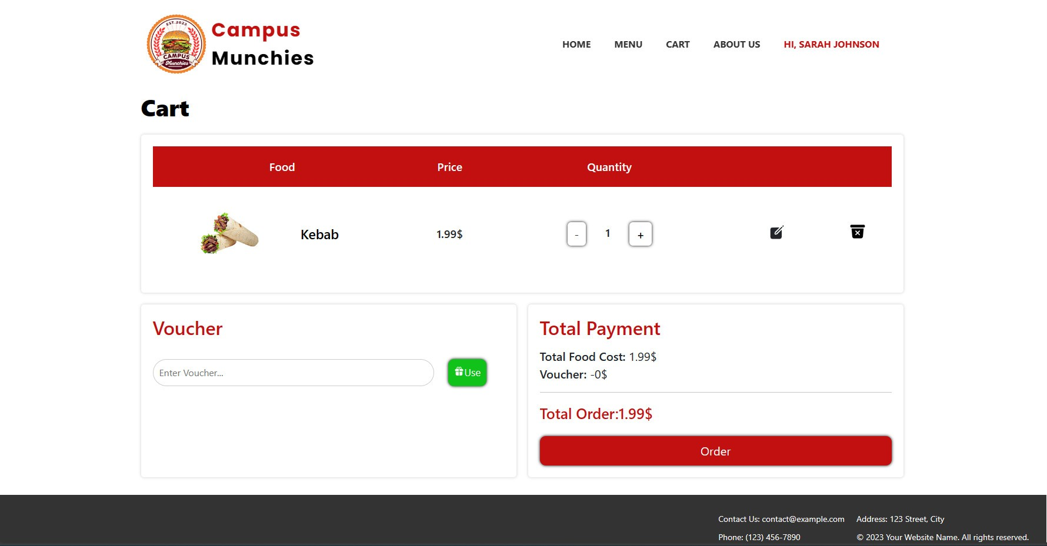

### Show/Edit cart and order

* Function trigger: When clicking the “Cart” button on the Home page
* Function description: Show all the food they want to buy, they can remove, change the quantity of the food and add note
* Screen details: Show information like address, phone number before customers order



Function details: Customers can choose the food and change quantity, after making the decision can press “Order” to order, and customers can order by COD or online banking. After buying, it will give you a bill with the order ID.

### Show Orders

* Function trigger: When clicking the “Order Status” button on the Home page
* Function description: Show all the orders they have already bought
* Screen Layout: Easy to view, enough information

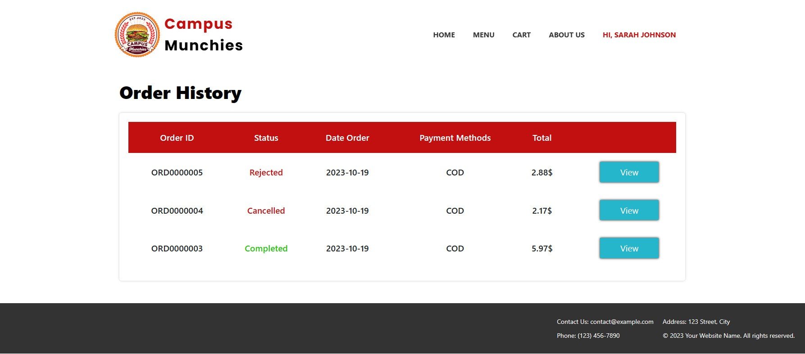

* Function details: Customers can view all orders and information of an order such as date, status, total, etc

## 3. Food Management

### a. Update Food

* Function trigger: When manager clicking the “Update” button on the Menu or Detail Product page
* Function description: Show the information of the food
* Screen Layout: Use paging to easy to see

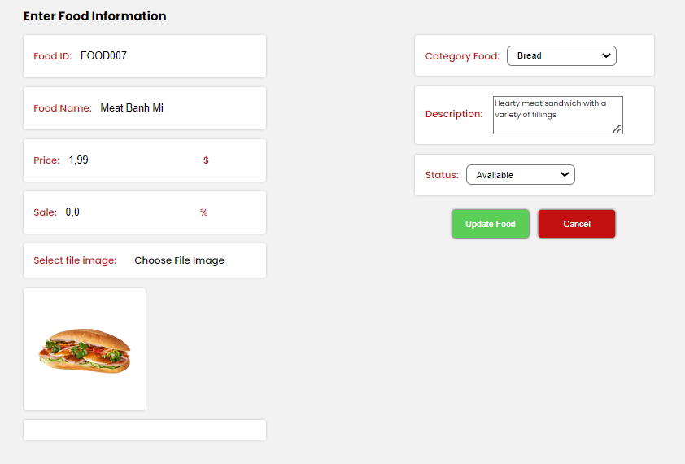

* Function Details: Managers can change the information such as name, price, picture, etc the click Update Product to Product

### 

### b. Delete Food

* Function trigger: When manager clicking the “Delete” button on the Menu or Detail Product page
* Function description: Show all the food on this page
* Function details: Click “Delete” to delete food

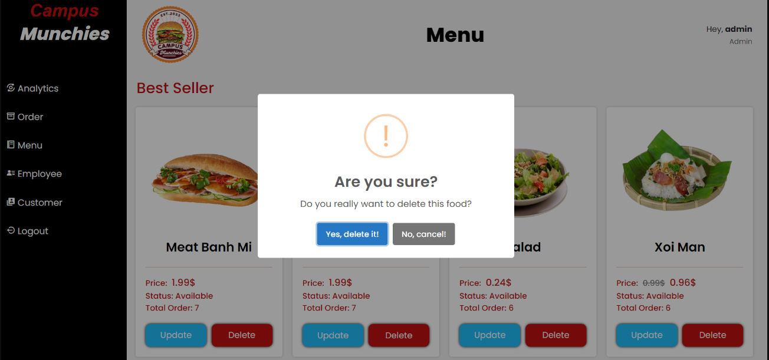

### c. Add Food

* Function trigger: When manager clicking the “Add Product” button on the Menu or Detail Product
* Function description: For managers who want to add new food to the menu.
* Screen Layout: The screen provides enough form of the food for the manager to enter

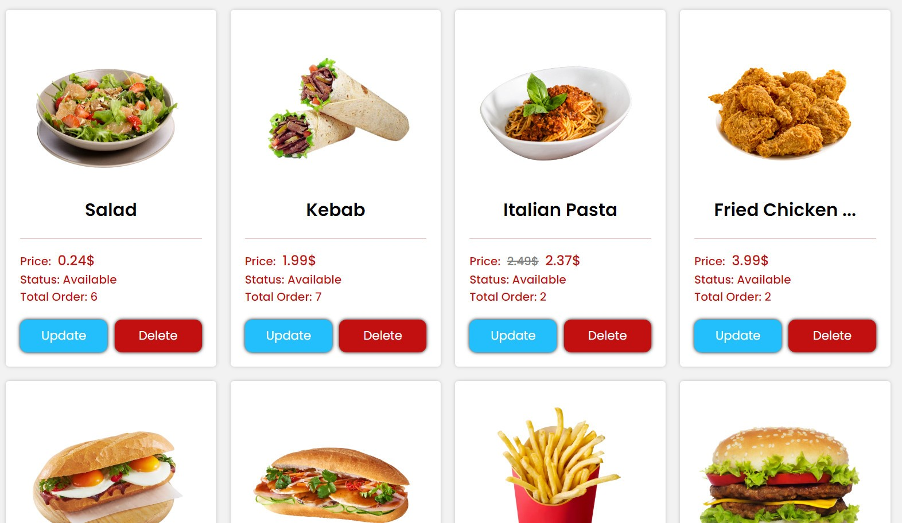

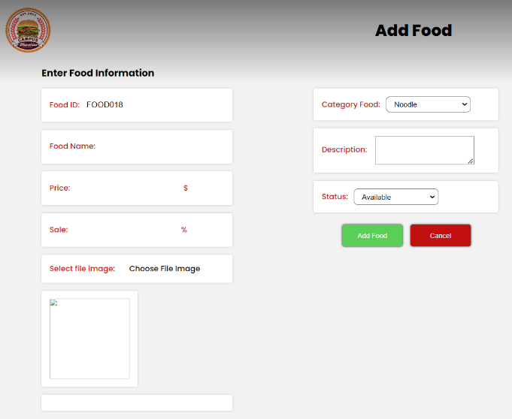

* Function Details: Managers can enter the information of the food and put it in database

## 4. Account Management

### a. View employee and customer information

* Function trigger: Click “Customer” or “Employee” in manager home page and
* Function description: Show the information of customers and employees
* Screen details: Show enough information about customers and employees

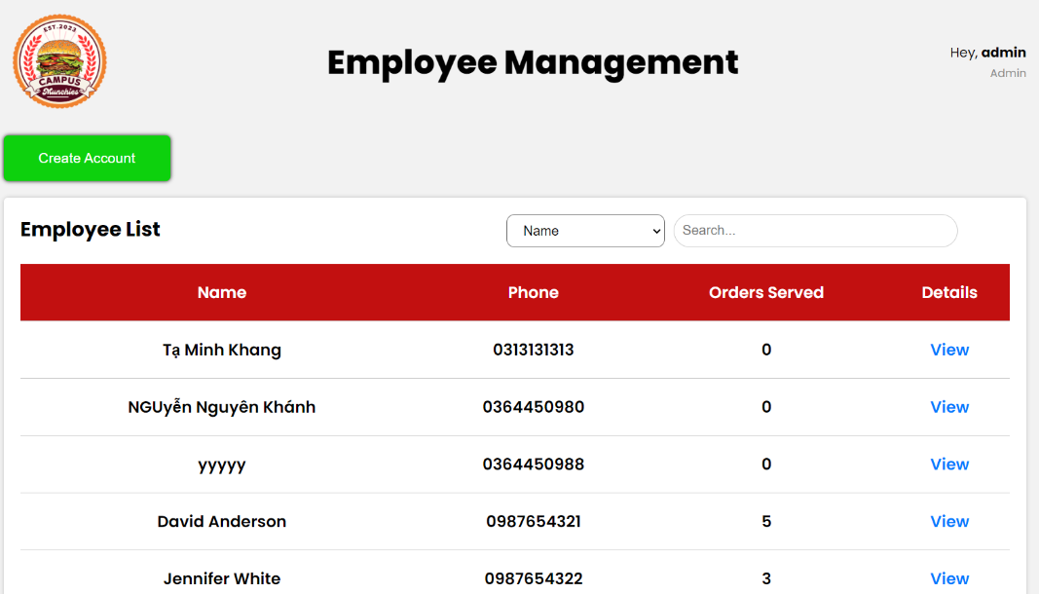

* Function Details: Manager can edit employees and customers information

### b. Create account

* Function trigger: Click “Create Account” on Employee Management
* Function description: Managers can create new employees

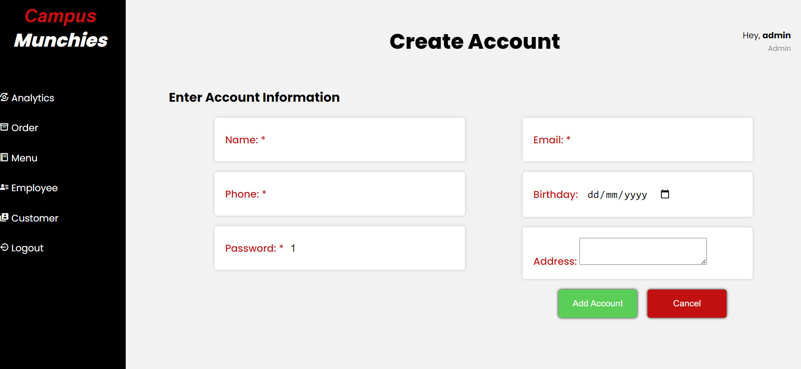

* Function Details: Only managers click “Create Account” to create new employees account

### c. Delete account

* Function trigger: Click “Delete Account” on Employee Information or Customer Information after
* Function description: Managers can delete employees or customers

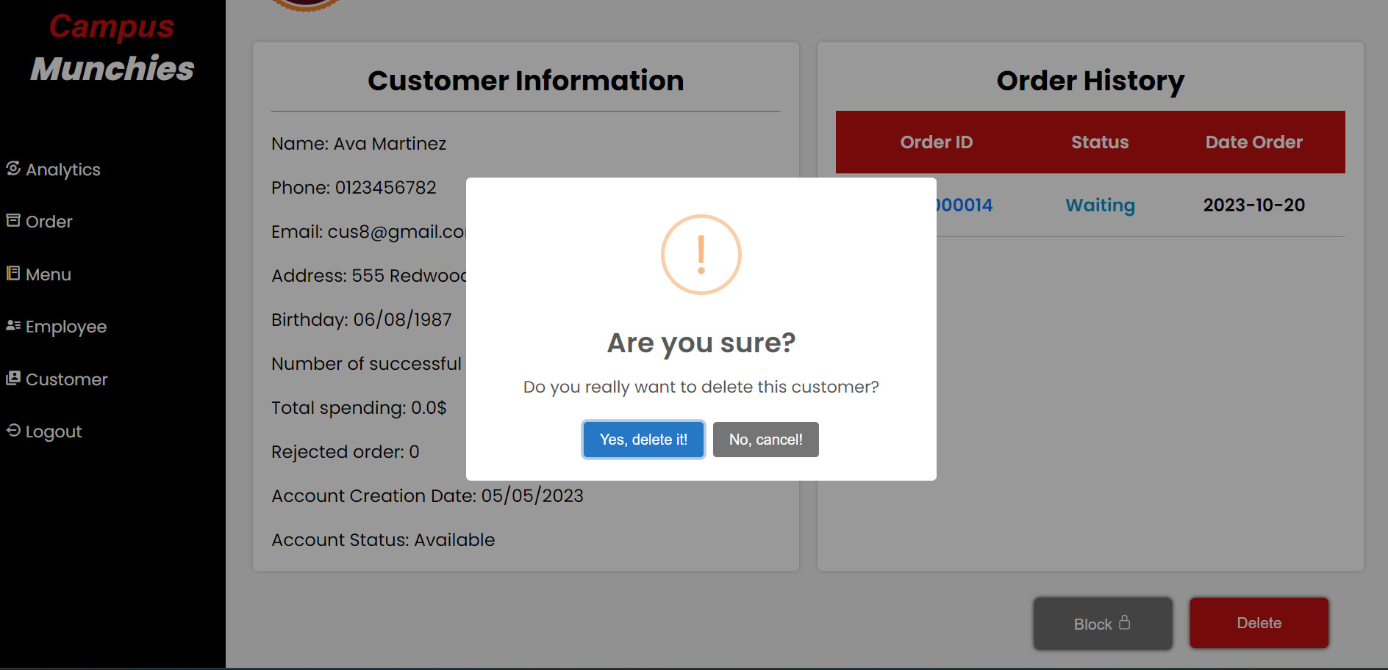

* Function Details: Only managers click “Delete Account” to delete that account

### d. Block account

* Function trigger: Click “Block Account” on Customer Information after
* Function description: Managers can block customer

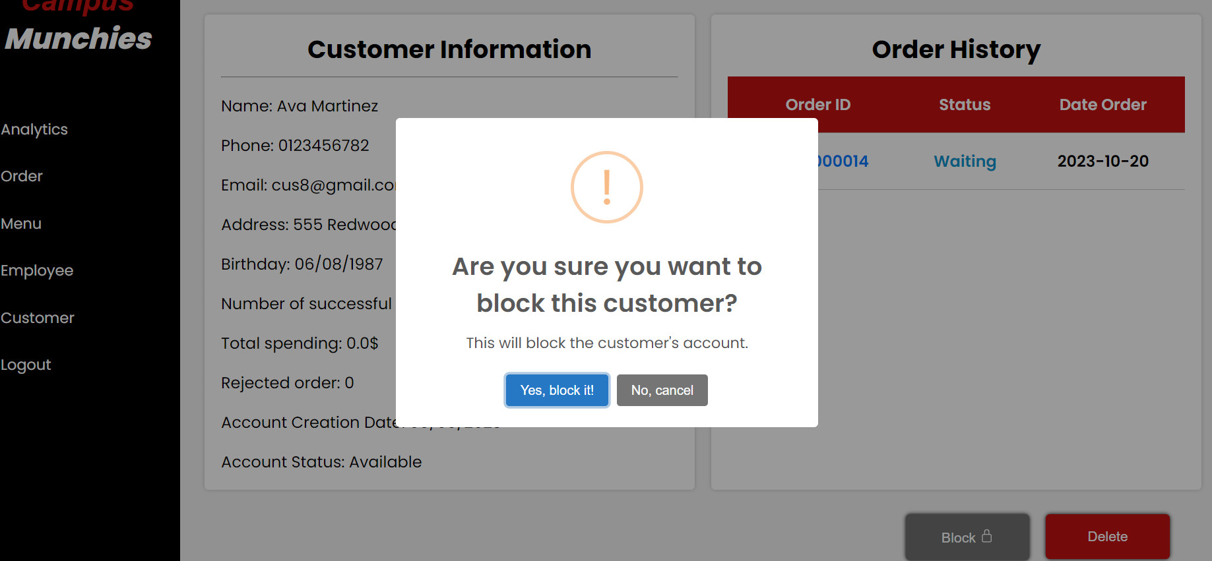

* Function Details: Only managers click “Block Account” to delete that account

## 5. Order Management

### Order Details

* Function trigger: Click “Order Status” on Managers home and Employees home
* Function description: Managers and Employees can view the customers’ orders list
* Screen details: Show enough information

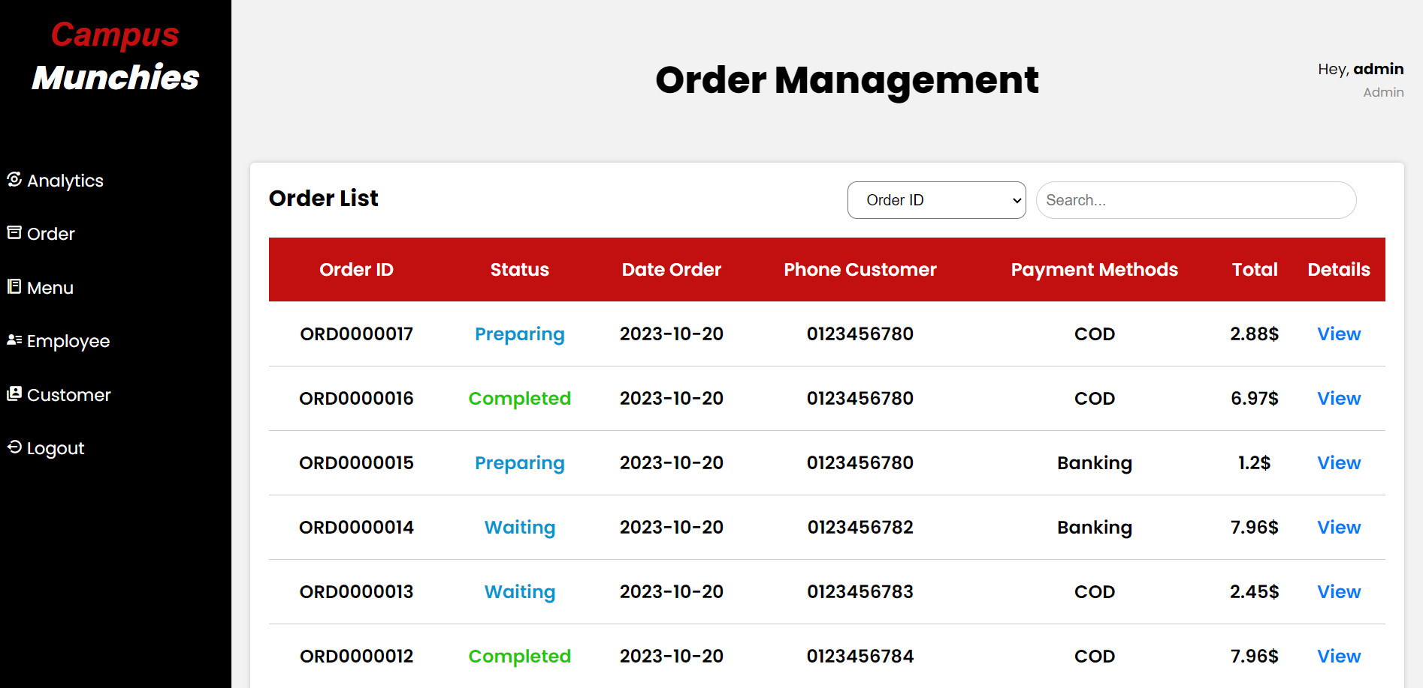

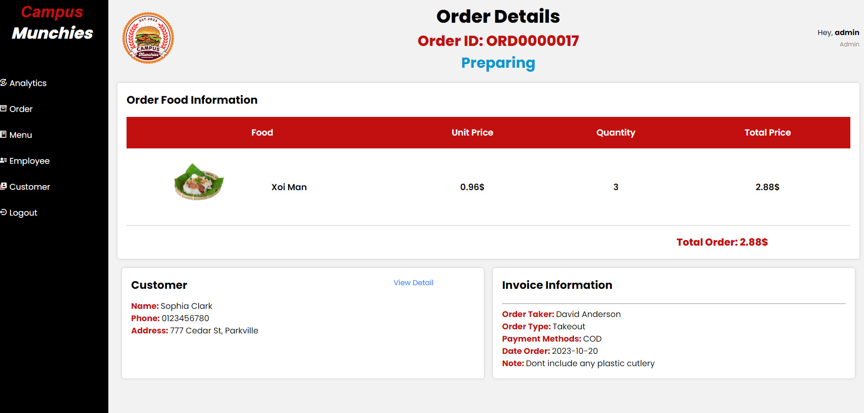

* Function details: Managers and Employees can view who manages the order, who orders the customer, etc. Employees can edit the order status

### Analytics

* Function trigger: Click “Analytics” on Managers home
* Function description: Managers can view total user, paid orders, revenue, etc
* Screen details: Show enough information

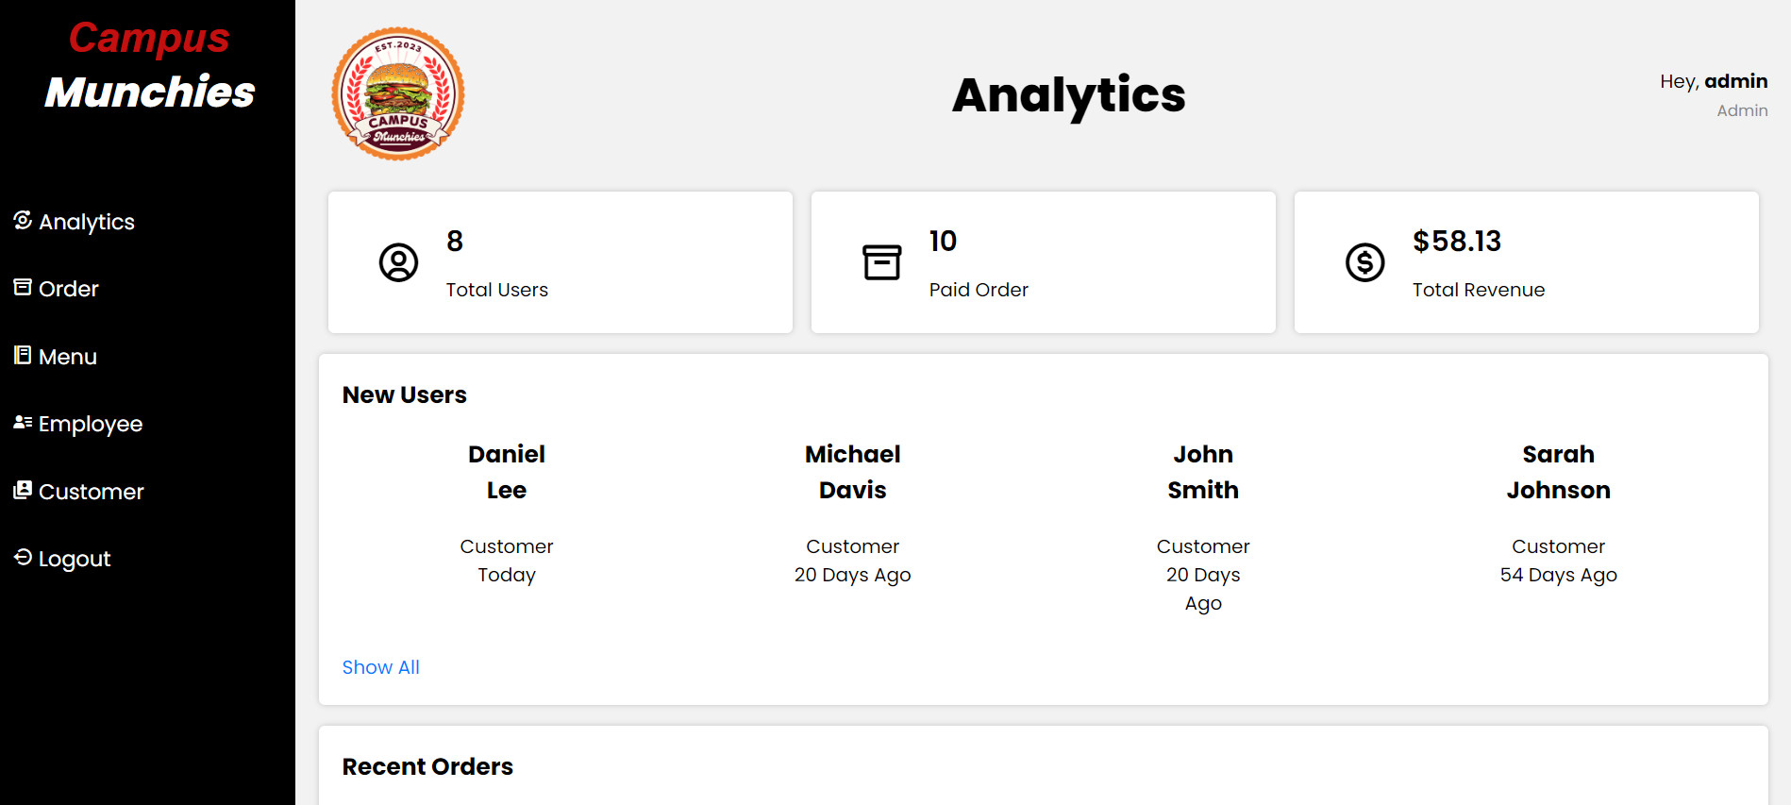

* Function details: Manager can view the revenues for each month, etc

### Change status order

* Function trigger: Click “View” on Managers home
* Function description: Customer can change status order
* Screen details: Show enough information

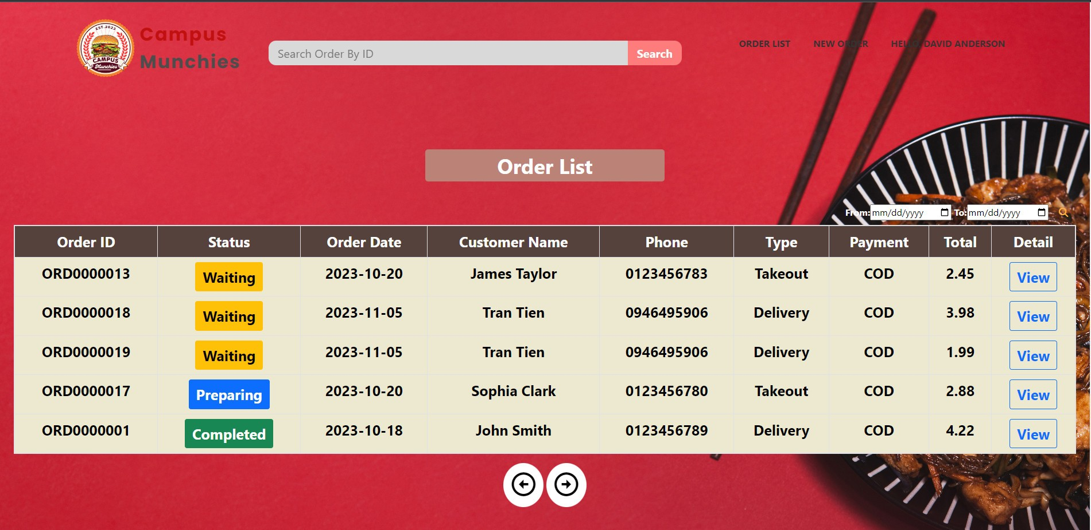

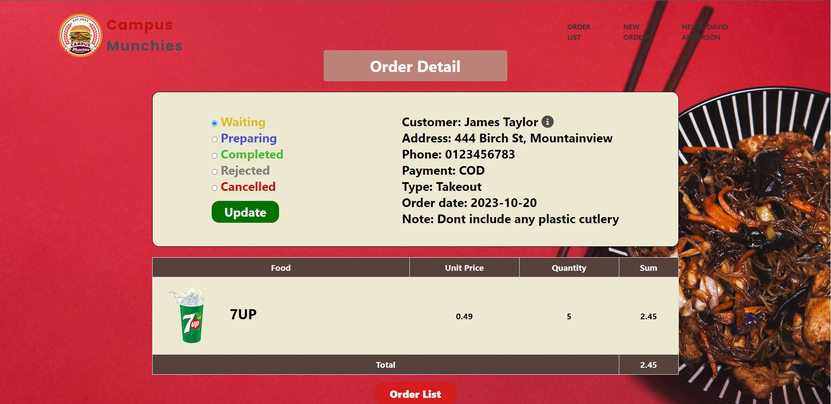

* Function details: Employee can view order status, customer name, etc